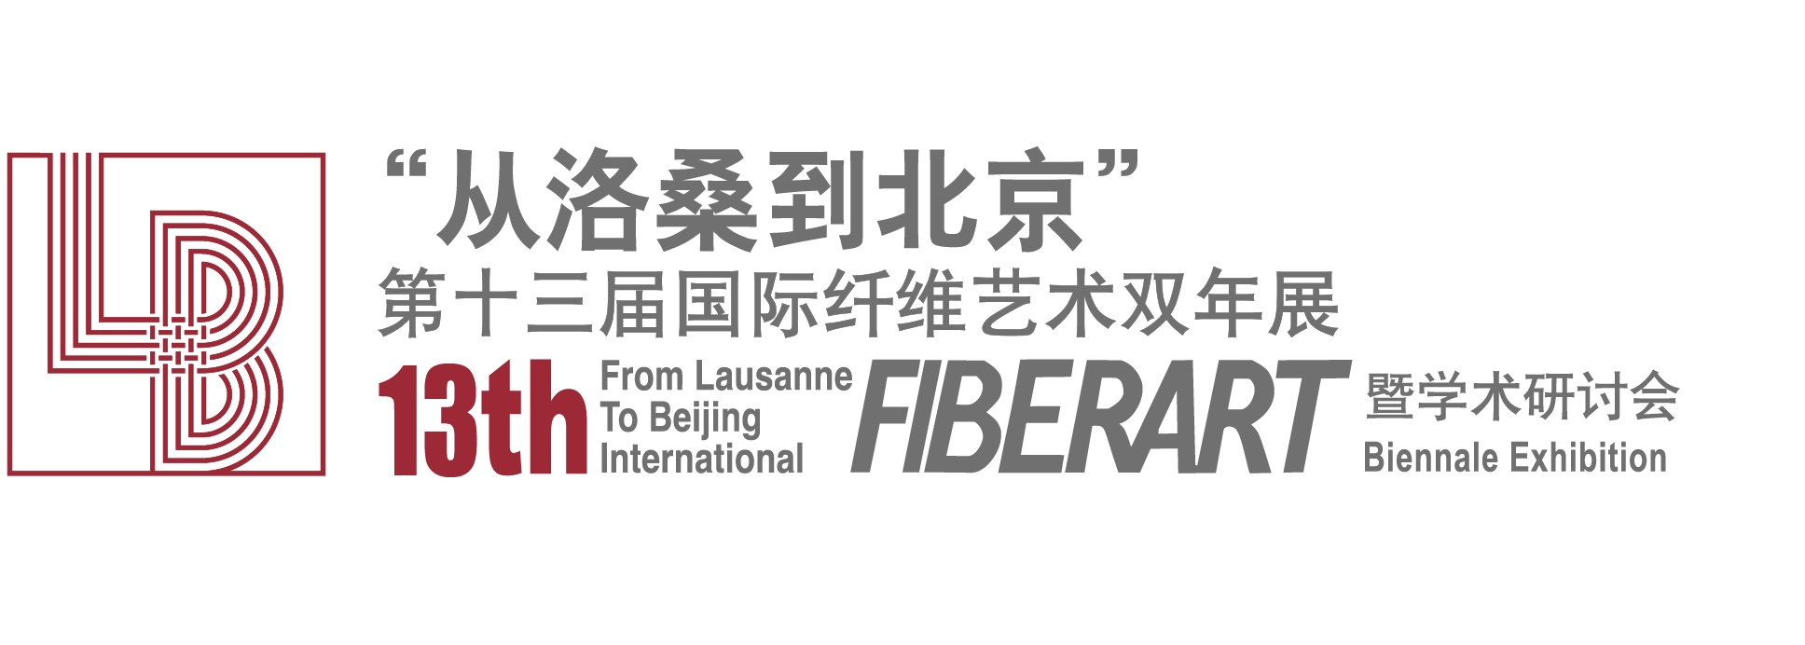

报名表Application Form
姓Last name / Surname | 名First name / Given name |  |  |  | 照片  Photo
出生日期Date of birth (MM-DD-YYYY) | 性别Gender |  | 国籍Nationality
通讯地址Address

邮编Zip code / Postal code/ Country | 电话Telephone number(s)
传真Fax | 电子信箱E-mail
单位Institution / Company

职务/职称Position

作品名称Title of work(s) |  | 作品完成时间Year completed
尺寸Size（cm）  长Length 宽Width 高Depth |  |  |  | 重量Weight(Kg)
展示方式Display Method

材料Material(s)

作者简历及主要参展和获奖情况 200字以内Artist's CV (including major exhibitions and awards) (Max. 200 words)

作品创作说明300字以内 Artist's Statement (Max. 300 words)

19. 本人同意遵守“从洛桑到北京”十三届国际纤维艺术双年展的全部规定
I agree to comply with all regulations of “From Lausanne to Beijing” 13th International Fiber Art Biennale

作者签名Signature： 日期Date:
20. 本人同意参展作品由委托组委会组织收藏。自定作品价格：____________人民币
I authorize the organizing committee may arrange for the collection of my exhibited work.
Self-determined price: ￥____________ CNY.

作者签名Signature: 日期Date:

(请通过电子邮件提交你的作品及报名表: lb_fiberartint@vip.163.com)
(Please submit your works and application form by E-mail to: lb_fiberartint@vip.163.com)
(每位艺术家提交一幅作品图片及作者照片，像素在2M-5M之间)
(Each artist submits one work picture and artist photo with the image size during 2M to 5M)
截止日期：2025年7月25日, Submission deadline: July, 25th, 2025)

